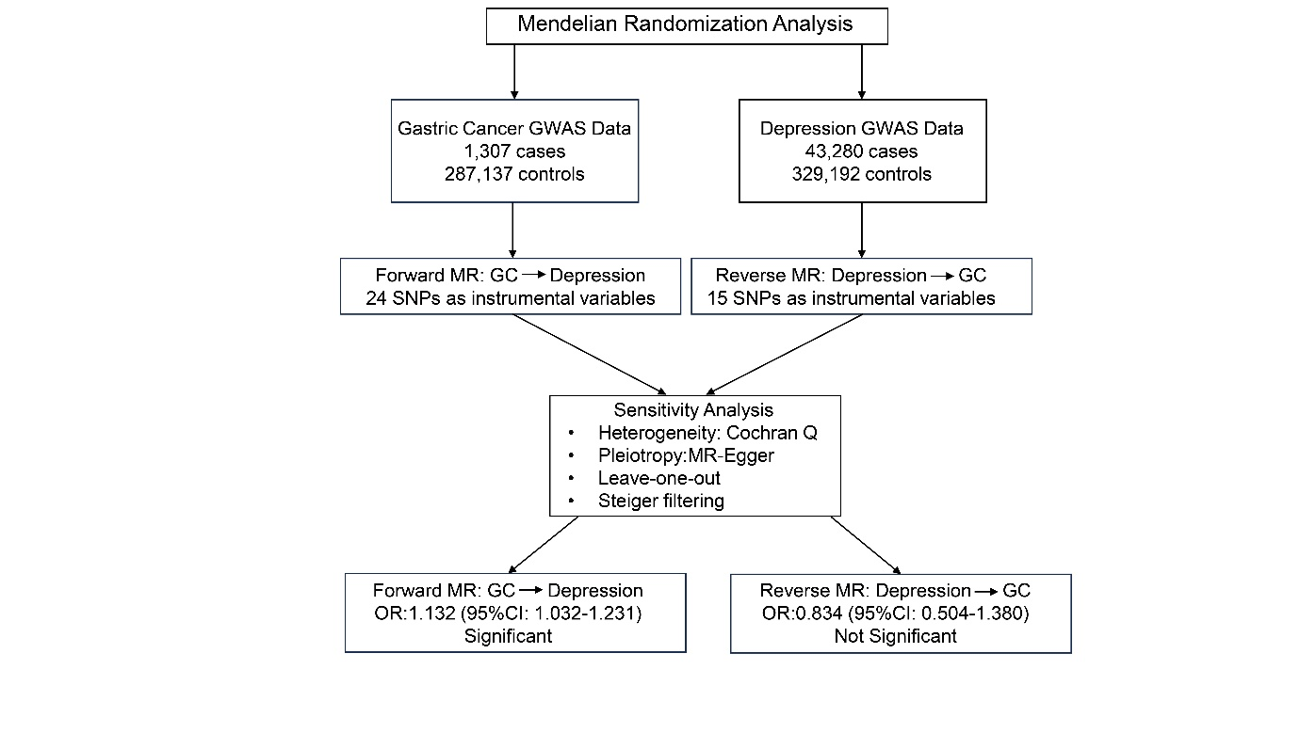
Supplementary Fig. 1. Flowchart of the bidirectional Mendelian randomisation analysis. GWAS, genome-wide association studies; MR, Mendelian randomization; OR, odds ratio; CI, confidence interval; GC, Gastric Cancer.

